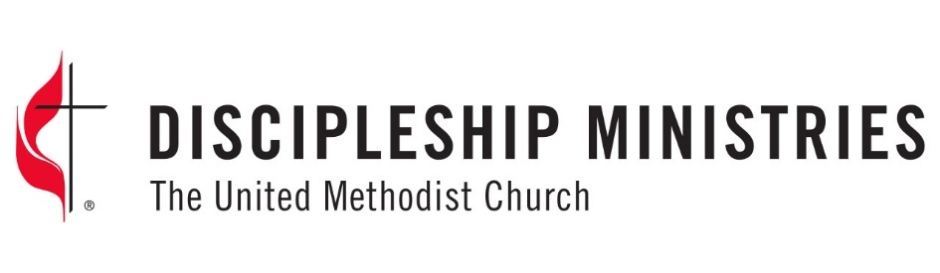
Racial Ethnic Local Church Concerns Grant Application Instructions
Applications must be received on or before August 15, 2026.

All applications, including supporting documents, must be complete at submission to be considered.

APPLICATION FORM INSTRUCTIONS
The application includes five components. When writing your application, take care to include all necessary documentation.
- Application form (completed online)
- Application narrative (Uploaded document; described below)
- Budget form (Uploaded worksheet. Form provided.)
  - Any budget item with a value greater than $1,000 should be explained in the narrative.
- Endorsements
Endorsements are intended to indicate that the required endorsers (all named below) are aware of the program and support it. They do NOT need to be full letters of recommendation.
- Grant applicants will request endorsements from the individuals specified below.
- Endorsers will email the endorsements to: grants@umcdiscipleship.org
- Endorsements must be received by the application deadline. The following endorsements are required:
  - Bishop
  - District Superintendent or Conference Connectional Ministries Director (whichever is most appropriate to your project)
  - Conference treasurer
  - Local Church pastor (ONLY for a local church sponsored ministry/project not being submitted by a local church pastor)
  - Caucus chair (ONLY for grant applications being submitted by anyone representing one of the five official racial/ethnic caucuses of the UMC)
- Please note that some conferences need several weeks to complete endorsements, especially from bishops and conference treasurers. It is the applicant's responsibility to ensure that ALL required endorsements are submitted by the grant deadline.

PROJECT NARRATIVE DETAILS
The narrative must address the following questions. After writing the narrative, please upload it as a pdf.

- Need statement: As specifically as possible, describe the need you want to address and how you seek to do so. Use the following questions to guide your response:
  - What is the problem, challenge, or opportunity that you are seeking to address through the ministry you hope to fund?
  - About how many people do you expect to directly impact through your project?
  - Have the persons who will benefit from this project been involved in discussion about your ideas related to need and project?
  - Are others addressing the need you've identified? How are they doing so?
- Ministry/Project Outcomes: Please name the outcomes you are seeking to accomplish and how they will be measured when the project is evaluated. Remember: An outcome is not an activity. An outcome is the change in individuals and/or communities that you want the project to accomplish. What will be different if your program is successful? How will you know?
- Meeting the Outcomes of the Ministry/Project: This section should clearly describe what you are going to do to address the needs described in Point A. Be sure to address the following questions:
    - Who are the beneficiaries?
    - Who is providing leadership?
    - When and where are you going to implement the ministry/project?
    - Is this a new ministry/project or is it the expansion or redirection of an existing ministry/project?
    - What exactly will be done to meet the outcomes?
- Evaluation. How will you evaluate the ministry/project?

RELCC grants are offered by the four program agencies of the United Methodist Church (The General Board of Global Ministries, The General Board of Church and Society, The General Board of Higher Education and Ministry, and Discipleship Ministries). Each agency's program has slightly different foci. Applicants may not receive funds from more than one agency. We encourage applicants to carefully read the criteria and foci for each agency to determine the best fit for your program.

